**Program 18: Demonstrate using function from a module in another one.**

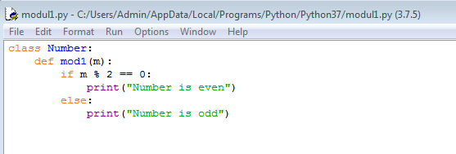

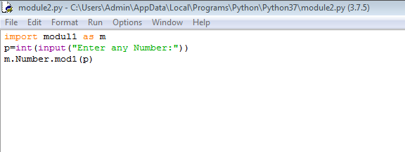

**Output**:

